A Homemade Cost-Effective High Performance Low Current Potentiostat, Supplementary Material
Using a Python Open Source Programming language with Qt to control the potentiostat
Abstract
We present an open source and multiplatform application written in Python using Graphical User Interface (GUI) implemented with Qt, to configure and control the differents potentiostat functions.

Graphical User Interface (GUI)
The user interface has been done using the Integrated Development Environment (IDE), Qt Designer, which is a Qt tool for designining GUIs with Qt Widgets, that allowed us to design a friendly application for the user and maintaining control of all potentiostat functionalities.

The application is multiplatform, being able to run on Windows, Mac or GNU/Linux operating systems.

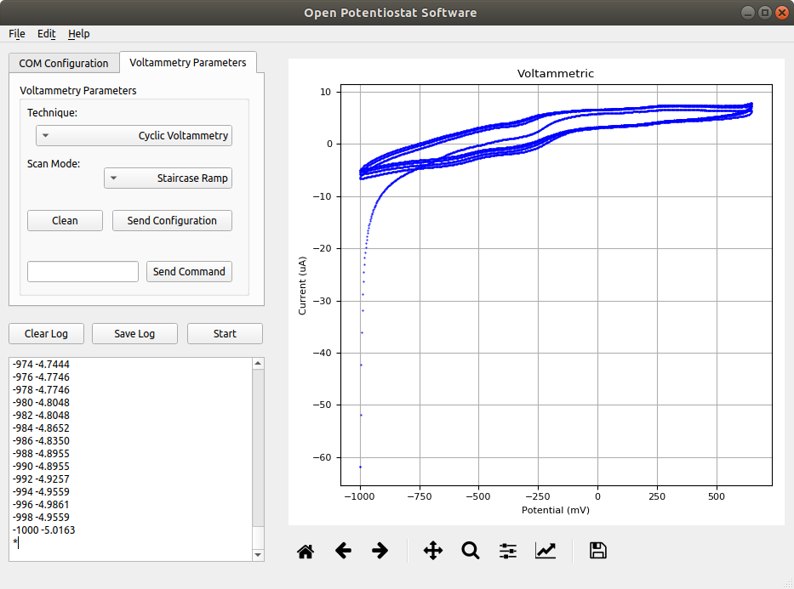

Fig. 1: Potentiostat Python Application running on Ubuntu 18.04 LTS

The developed program contains two tabs, the first of them allows to list the serial ports found, configure the baud rate and open the port corresponding to the potentiostat to begin with its use.

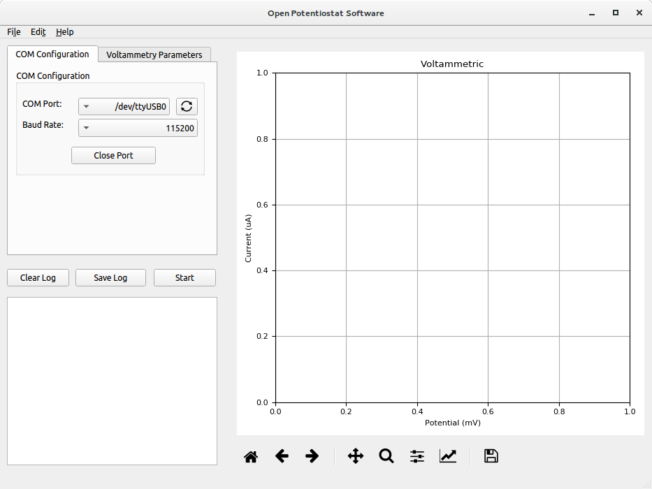

Fig. 2: COM Configuration tab
The second tab contains the parameters and main functionalities of the potentiostat, such as the type of voltammetry to be used and the type of signal that is sent to the cell, which are set on the device by pressing the "Send Configuration" button. A QLineEdit was added to send any command or parameter value to the potentiostat using the "Send Command" button.
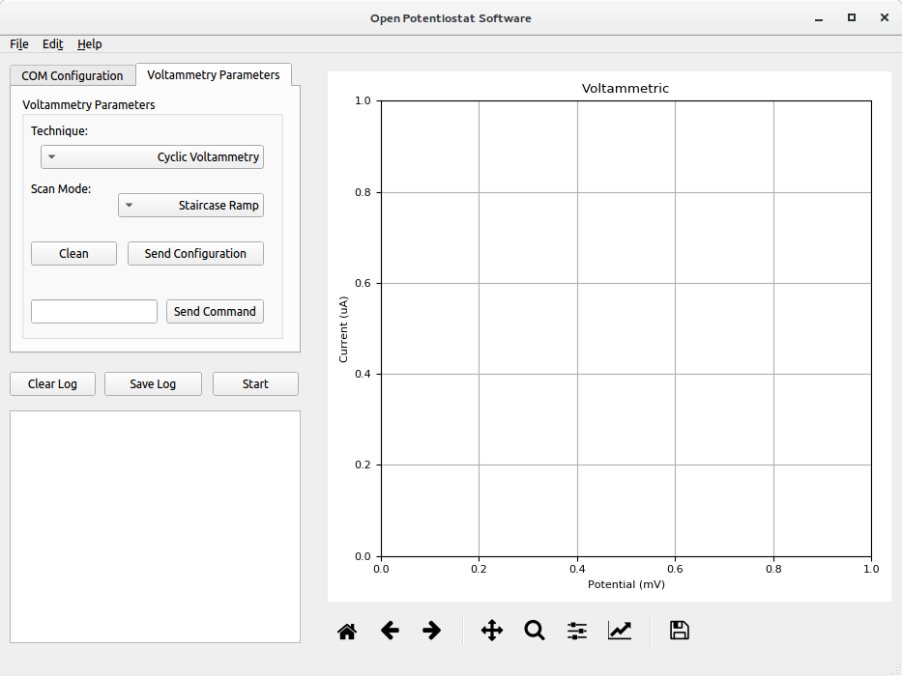

Fig. 3: Voltammetry Parameters tab

In the lower left there is a QPlainTextEdit where the user can see the data sent by the potentiostat, which can be saved in a file with “.log” extension by the "Save Log" button or deleted from the QPlainTextEdit by pressing the "Clear Log" button, this button also allows to delete the data plotted in the Matplotlib widget.
The process can be started sending the letter "s" using the QLineEdit and the "Send Command" button or pressing the “Start” button that also reads the values ​​selected for the technique and the scan mode to be used.

Python Application

The Python application contains four files, the first one is the "gui.py" file, which is a python script where all the widgets used in the GUI are instantiated, this file was generated by the pycui5 tool, from the ".ui" file created in Qt Designer.
The second file "mplwidget.py" allows to use a matplotlib widget from the Matplotlib canvas class (through which the data sent by the potentiostat can be plotted), within the QGraphicsView added in QtDesigner.
The "SerialThread" script allows to control the serial port by means of threading using the python library with the same name, this is done with the purpose that the graphical user interface does not remain frozen while receiving data through the serial port, avoiding the loss of said data.
The last one is the main file “main.py”, where all the functions corresponding to the events and signals generated by the buttons and other widgets are located, as well as the functions where the data sent by the potentiostat are acquired and accommodated for visualization and plotting. This script is the one that must be run to visualize the graphic user interface and use all its functionalities.

Plotting Data

The Python 2D graphics library Matplotlib, was used to plot the data sent by the potentiostat; using a promoted QgraphicsView widget, a chart was created with different utilities, such as the zoom to rectangle tool or save the figure, that could be useful for the user to generate experiments documentation. This widget can plot differents data arrays, depending of the technique type used.

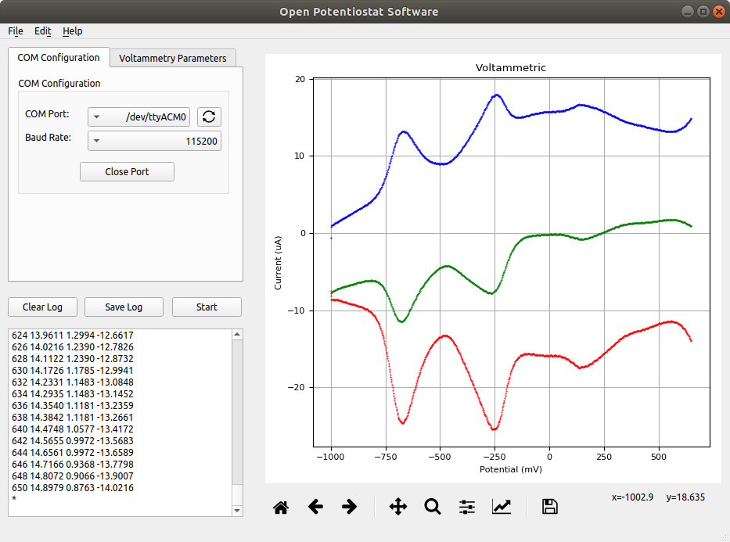

Fig. 4: Example of Annodic Stripping Voltammetry.

Resources

Python 3
https://www.python.org/doc/

PyQt5
https://pypi.org/project/PyQt5/

Matplotlib
https://matplotlib.org/

PySerial
https://pythonhosted.org/pyserial/

